WELCOME TO THE HOW-TO FOR SUBMITTING
your CONTENT to the CDCDA website

- Hit the blue CLUB button at the top of the CDCDA website home page (www.communitydance.org)
- At the very bottom of the page click the Member Content Submittals Tab. 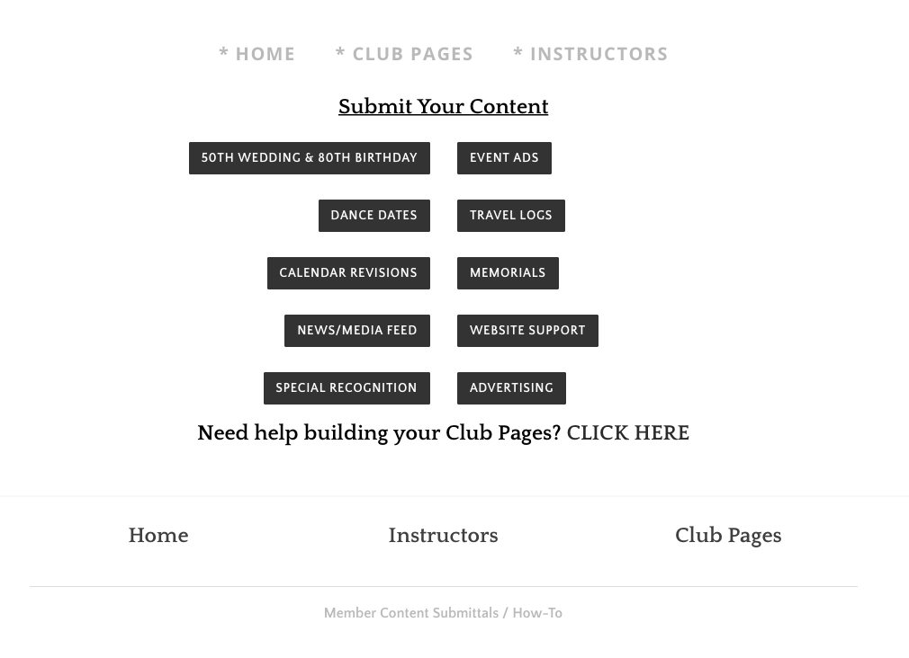
- Click on the appropriate box for the event or announcement that you would like to add to the website.
- Fill in all the boxes with your info. Any box marked with a red * is a required field.
- To upload your poster or pictures click on the Choose File tab in the first box under Poster or Pictures.
- Clicking the Choose File tab will open a place on your computer where you can find your documents/poster/picture. Click the document you wish to add and select the Open/Choose button, it will upload to the box.
- To add another poster/document follow step 6 again but pick the next available box. Each poster/document must be in a separate box, (1 of 5, 2 of 5, etc.)
- Once your information is completed and posters/pictures/files are uploaded hit the black SUBMIT box.
- You’re done! We will take care of the rest. Changes may take up to 48 hours to appear.

