Step by step instructions to upload your material to the CDCDA website www.communitydance.org

- Go to www.communitydance.org
- Hit the blue CLUB tab button at the top of the page.
- At the very bottom of the page click the Member Content Submittals Tab. 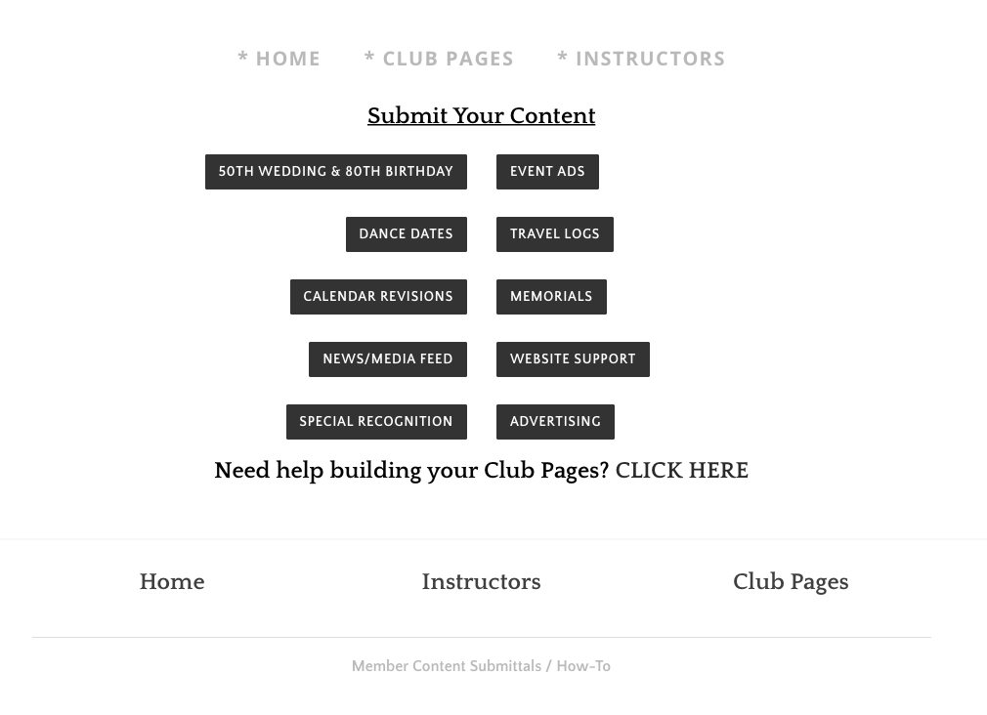

- Click the Event Ads Tab, Dance Dates, or Anniversary and Birthdays tabs to impute your announcement.

- Fill in all the boxes with your info. Any box marked with a red * is a required field.
- To upload your poster or pictures hit the first box and click the Choose File tab.
- Clicking the Choose file tab will open up your documents in your computer. Click the poster you wish to add and select the Choose button, it will upload to the box.
- To add another poster follow step 6 again but pick box 2 of 5, each poster must be in a separate box, (1 of 5, 2 of 5, etc.)
- Once your information and posters/pictures/files are completed hit the black SUMMIT box.
- You’re done! We will take care of the rest.
- Changes may take up to 48 hours to appear.

